Political Campaign

# Ohio

<http://www.270towin.com/states/Ohio>

Stats

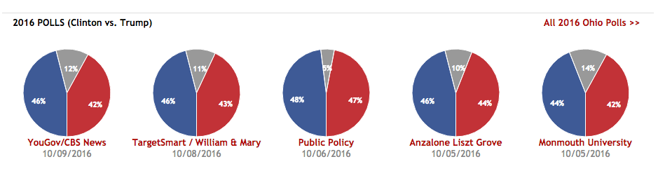

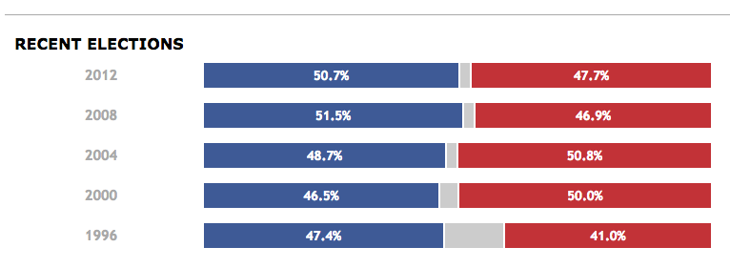

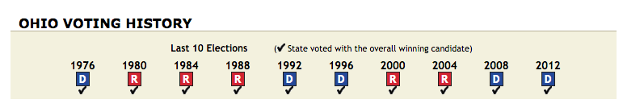

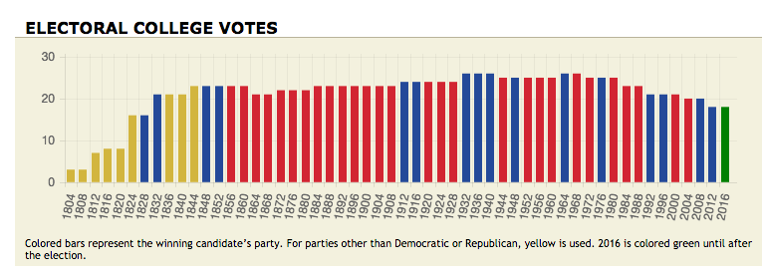



Blue = Democratic

Red = Republican